Learning Curve Calculations
1.A job has an 80 percent learning curve. The second unit required 32 hours to complete. Approximately how many hours will be devoted to the first ten units (including those already completed)?
A.25.2
B.252
C.202
D.320
E.28
F.can't tell unless we know demand.

3.Who is learning fastest?
A.Joe, who takes 8 hours to do the first piece and has a 70% learning curve
B.Mary, who takes 7 hours to do the first piece, and has an 80% learning curve
C.Tom, who takes 6 hours to do the first piece, and has an 80% curve.
D.Marvin, who takes 5 hours to do the first piece and has a 75% curve
E.Tony, who still hasn't finished the first piece and probably never will, because he's still trying to calculate the natural logs in the formulas, following the MITDC method
F.Yolanda, who took 9 hours to do the first piece, and has a 60% learning curve
G.Joe and Mary are learning at about the same rate

4.A manager is trying to estimate the appropriate learning curve for a certain job. The first twenty units had a total time of 730 minutes. The first unit took 50 minutes. If these data are reliable and fit the theory, which learning curve fits this best?
A.0.70
B.0.75
C.0.80
D.0.85
E.0.90

Critical Paths and Crashing Projects
The Vice Presidents want to knock five months off this project because they expect to save $3000K per month by finishing early, and five months sounds like a round understandable goal to present to the president without giving him too much information.
Activity  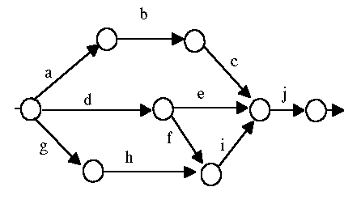 |  | time |  | Crash Cost per month
a |  | 6 |  | $100K
b |  | 5 |  | $2000K
c |  | 8 |  | $150K
d |  | 4 |  | $1500K
e |  | 3 |  | $2800K
f |  | 9 |  | $2,000K
g |  | 5 |  | $1500K
h |  | 3 |  | $500K
i |  | 15 |  | $3500K
j |  | 2 |  | $3400K
The original length of this project is:
Why?

Joe Knowitol got his MBA from the Coastal Holistic University Garden (C.H.U.G.) where requirements are flexible, courses are quick, and they bill your company direct. Joe proposed a plan to crash 5 months and Proclaims:

"net result, 5 months crashed @ $3000K per month saves $15000K-$6150K cost gives $8850K improvement."

Joe is hailed as a hero.

There are some very specific problems with each part of Joe's plan. What are they?
What's wrong with these? Hint: this is really a very easy question, there is no need to figure out a good full crashing scheme, just identify the obvious problems with each of Joe's ideas.
1.A $100K 1 month
2.C $150K 1 month
3.H $500K 1 month
4.F $2000K 1 month
5.J $3400K 1 month
Total $6150K cost

Joe is your boss. What are three approaches you could take (politically) to avoid a disaster?
1.
2.
3.

