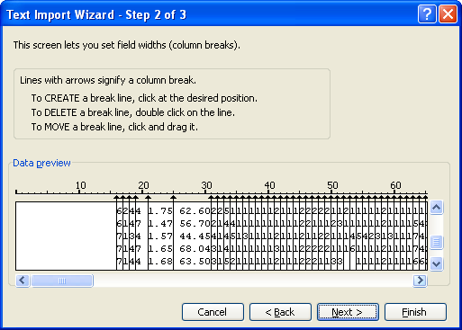
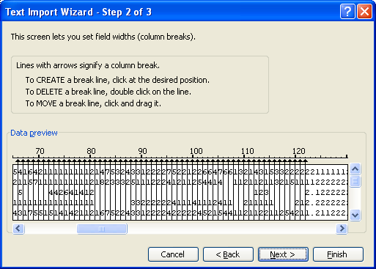

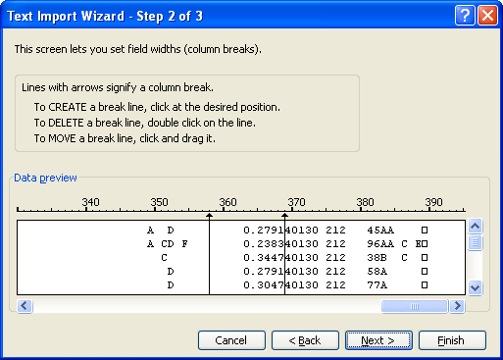
YRBSS 2005 parsing into EXCEL
The first columns include site codes etc, so you might want to skip those and start at column 17, question 1, age.
All are one digit (column) variables except for Q4 (columns 21-22), derived ethnic variable, height Q5 (22-25), weight, Q6 (26-31). The primary questions go out to Q97 (122). You might also want to mark off and import the statistical weighting constants (358-369) so you can use these as a basis for counts rather than raw numbers of records to get statistics more representative of the total US highschool population.
Others You might skip:
Columns 223-349 are vacant and then , at the end, race/ethnicity as originally scanned, Q4orig (350-357), stat wt (358-369), Primary Sampling Unit, PSU (370-374), Stratum (375-378), BMIpct, percentile for body mass index (379-383). The last columns are Ethorig, ethnicity as originally scanned (384) and Raceorig, race as originally scanned (385-389).
The way I’ve marked these off, I was preparing to skip columns 123-357 to save file size, as those are all derived variables. However, with USB flash memory drives, file size is no longer a huge issue and so, if you want to include those, just mark them all off as one-column variables. Beware, that the grouping of responses used by CDC may give misleading conclusions.

