Exposition of Simpson’s Paradox Using PivotTables in Microsoft EXCEL
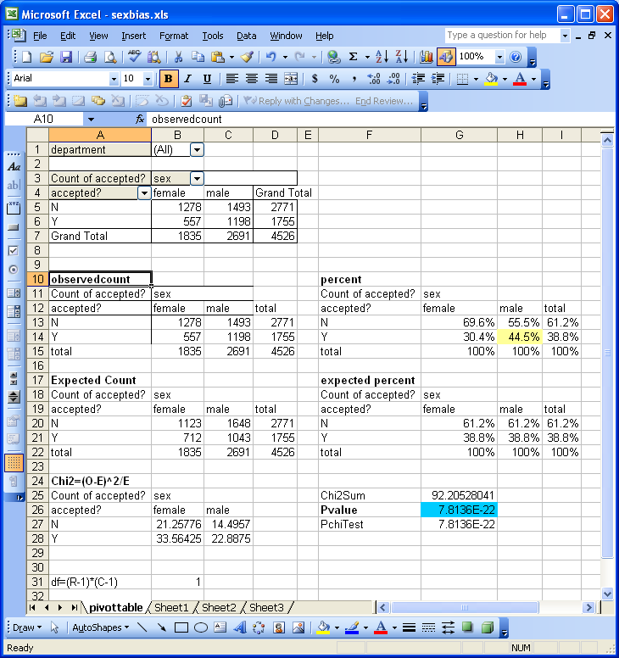
Here are screen captures showing layout and formulas for use in a four-cell crosstabulation in EXCEL.
The data is a partial from the classical Berkeley Graduate School Admissions sex-bias case in which proportions for admissions data aggregated over departments gave a clear indication of bias toward males in graduate school admissions. Inclusion of a Department variable as a page variable in cell B1 allows filtering to give subgroup results. What we learn from this is that even very high confidence in a conclusion is not “proof.” Our understandings of situations may change as a result of digging further into the data. Sometimes, aggregations of data may be inappropriate because there are other variables lurking in the subsets that could change the interpretation substantially.

The partial dataset was obtained from Gerstman B.B. (2000) Data Analysis with Epi Info, Binary Outcome, Stratified Analysis on the web at http://www.sjsu.edu/faculty/gerstman/EpiInfo/stratified.htm
Some other useful links on this topic:
http://plato.stanford.edu/entries/paradox-simpson/
http://www.google.com/search?hl=en&q=simpson%27s+paradox
http://core.ecu.edu/psyc/wuenschk/StatHelp/Reversal-Paradox.txt
http://repository.upenn.edu/cgi/viewcontent.cgi?article=1014&context=wharton_research_scholars
http://wolfweb.unr.edu/homepage/jerryj/NNN/Aggregates.pdf

